A Group Project Report
on
CARTOONIFYING AN IMAGE

Submitted in partial fulfillment of the requirement
For
The award of degree of

BACHELOR OF TECHNOLOGY

in
COMPUTER SCIENCE & ENGINEERING
2019-2023

Submitted By
Kalla Goutham | 19311A0503
Chigullapalli Prem Sai | 19861A0557
Nomula Siddartha Reddy | 19311A0539

Under the Guidance of

Dr. H.Balaji
Associate Professor


Department of Computer Science & Engineering

SREENIDHI INSTITUTE OF SCIENCE AND TECHNOLOGY

(AUTONOMOUS)
Yamnampet (V), Ghatkesar (M), Hyderabad – 501301, A.P.

AY-2021-2022
Department of computer Science and Engineering

Sreenidhi Institute of Science and Technology

CERTIFICATE

This is to certify that this Group Project report on “Cartoonifying an Image”, submitted by Kalla Goutham(19311A0503) , Chigullapalli Prem Sai(19861A0557) , Nomula Siddartha Reddy(19311A0539) in the year 2022 in the partial fulfillment of the academic requirements of Jawaharlal Nehru Technological University for the award of the degree of Bachelor of Technology in Computer Science and Engineering, is a bonafide work that has been carried out by them as a part of their Group Project during Third Year Second Semester, under our guidance. This report has not been submitted to any other Institute or university for the award of any degree.

Internal guide | Project Coordinator | Head of the Department
Dr.H.Balaji | Dr.R.Lakshmi Priya | Dr. Aruna Varanasi
Associate Professor | Associate Professor | Professor & HOD
Department of CSE | Department of CSE | Department of CSE

Signature of the External Examiner

Date:-

DECLARATION

We Kalla Goutham(19311A503) , Chigullapalli Prem Sai(19861A0557) ,Nomula Siddartha Reddy (19311A0539) students of SREENIDHI INSTITUTE OF SCIENCE AND TECHNOLOGY, YAMNAMPET, GHATKESAR, studying III year II semester, COMPUTER SCIENCE AND ENGINEERING solemnly declare that the Group Project work, titled “ Carttonifying an Image” is submitted to SREENIDHI INSTITUTE OF SCIENCE AND TECHNOLOGY for partial fulfillment for the award of degree of Bachelor of technology in COMPUTER SCIENCE AND ENGINEERING.

It is declared to the best of our knowledge that the work reported does not form part of any dissertation submitted to any other University or Institute for award of any degree.
ACKNOWLEDGEMENT

I would like to express my gratitude to all the people behind the screen who helped me to transform an idea into a real application.

I would like to express my heart-felt gratitude to my parents without whom I would not have been privileged to achieve and fulfill my dreams. I am grateful to our principal, DR. T. Ch. Siva Reddy, who most ably runs the institution and has had the major hand in enabling me to do my project.

I profoundly thank Dr. Aruna Varanasi, Head of the Department of Computer Science & Engineering who has been an excellent guide and also a great source of inspiration to my work.

I would like to thank our Coordinator Dr.R.Lakshmi Priya & my internal guide Dr.H.Balaji for their technical guidance, constant guidelines, encouragement and support in carrying out my project on time at college.

The satisfaction and euphoria that accompany the successful completion of the task would be great but incomplete without the mention of the people who made it possible with their constant guidance and encouragement crowns all the efforts with success. In this context, I would like to thank all the other staff members, both teaching and non-teaching, who have extended their timely help and eased my task.

Kalla Goutham | 19311A0503
Chigullapalli Prem Sai | 19861A0557
Nomula Siddartha Reddy | 19311A0539

ABSTRACT

Before we need a skilled person to draw or convert an image into animated sketch or image. Later after the development in technology one needed high graphical based software to trace an image feature and shape the edges properly and add some extra features for being specific where a lot of knowledge or skill is needed even using technology also. As the technology is developing more and more day-to-day image processing came into existence which helped people or made the work easier for converting the image where image processing can be implemented using python along with the help of some libraries like open cv. OpenCV is a cross-platform library using which we can develop real-time computer vision applications. It mainly focuses on image processing, video capture and analysis including features like face detection and object detection.

LIST OF FIGURES
S.NO | Figure No. | Title of Figure | Page No
1 | 1 | Recombine Diagram | 15
2 | 2 | System Architecture Design | 20
3 | 3 | Data Flow Diagram | 21
4 | 4 | Use Case Diagram | 23
5 | 5 | Sequence Diagram | 24
6 | 6 | Activity Diagram | 25
7 | 7 | Sample Input Screen | 41
8 | 8 | Sample Output Screen | 42
9 | 9 | Input Image | 43
10 | 10 | Gray Scale Image | 43
11 | 11 | Edge Retrieved Image | 44
12 | 12 | Mask Image | 45
13 | 13 | Test Inputs | 46
14 | 14 | Test Outputs | 47
15 | 15 | Future Scope (Types of Images) | 49

\

LIST OF TABLES/GRAPHS
S.NO | Graph No. | Title of Graph | Page No
1 | 1 | K-means clustering Algorithm Graph 1 | 31
2 | 2 | K-means clustering Algorithm Graph 2 | 32
3 | 3 | K-means clustering Algorithm Graph 3 | 32
4 | 4 | K-means clustering Algorithm Graph 4 | 33
5 | 5 | K-means clustering Algorithm Graph 5 | 34
6 | 6 | K-means clustering Algorithm Graph 6 | 34
7 | 7 | K-means clustering Algorithm Graph 7 | 35
8 | 8 | K-means clustering Algorithm Graph 8 | 36
9 | 9 | K-means clustering Algorithm Graph 9 | 36
10 | 10 | K-means clustering Algorithm Graph 10 | 37
11 | 11 | K-means clustering Algorithm Graph 11 | 37
12 | 12 | K-means clustering Algorithm Graph 12 | 38

INDEX

 | Page No
List of Figures | 6
List of Tables | 7
- INTRODUCTION | 9-11
1.1 Project Introduction | 9
1.2 Project Purpose | 9
1.3 Project Overview | 10
1.4 Objectives | 11
- LITERATURE SURVEY | 12-15
2.1 Existing System | 12
2.2 Proposed System | 12-13
2.3 Related Work | 13-15
- SYSTEM ANALYSIS | 16-19
3.1 Functional Requirements | 16
3.2 Software Requirements | 17
3.3 Hardware Requirements | 18
3.4 Feasibility study (Technical/Economical/Operational) | 19
- SYSTEM DESIGN | 20-27
4.1 System Architecture Design | 20
4.2 Data Flow Diagram | 21
4.3 UML Diagrams | 22-24
4.3.1 Use Case Diagram | 22
4.3.2 Sequence Diagram | 23
4.3.3 Activity Diagram | 24
4.4 Modules | 25-27
- IMPLEMENTATION AND RESULTS | 28-42
5.1 Language / Technology Used | 28-29
5.2 Methods / Algorithms Used | 30-38
5.3 Sample Code | 39-40
5.4 Results (Accuracy) / Output Screens | 41-42
- TESTING | 43-47
6.1 Types of Testing | 43-45
6.2 Test Cases | 46-47
- CONCLUSION | 48
- FUTURE SCOPE | 49
- BIBLIOGRAPHY | 50
APPENDIX-A :
PLAGIARISM REPORT
ABSTRACT | 5
PROJECT CORRELATION WITH PO’s AND PSO’s
NATURE OF THE PROJECT
DOMAIN OF THE PROJECT | AI & ML

- INTRODUCTION

1.1 Project Introduction:

Web-based media is widely utilized nowadays. What’s more, hanging out in this online group has consistently been a to-do on each client been a to-do on each client’s rundown on these web-based media stages. Be it pictures, blog entries, work of art, tweets, images, conclusion and what not being utilized to look for consideration of supporters or companion to make impact or to interface with them on such friendly stages. We mean to give one such clever fix to their necessities, which is applying animation like impact to their picture. Client can later share these pictures on any friendly media stages, save it for themselves, share with family and do whatever they like with it. You can use utilize your very own profile picture, make an interesting symbol or transform your photograph into an animation with a pool of web application accessible on the web.
Image Processing is widely processed in the medical field such as in the MRI/ET scans [34]. The amount of research in the image processing has helped to acquire early detection of tumors. There plays a vital role in the field of image processing and in the field of Biology. This research bound to save livelihood as early detection can be identified and effective treatment can be started off. These extended concepts have enabled to build better security systems which ensure safety. The security/surveillance systems have managed to build systems depending on the image processing algorithms, The recent technology of fingerprint unlock, face detection unlock has resulted in developing an efficient security. These Biometric systems perhaps have been now installed on to smaller devices as well for the simpler usage. With the recent success apprehended by the social media is duly with the techniques installed to enhance the user experience. E.g. – Facebook confines with the auto tag mechanism to automatically suggest the person’s name and not by manually tagging each person on the image. The basic concept in this algorithm involves the technique of converting the RGB colour image to an accurate, cartooned image without multiple filtrations or blurred image without proper facilitation of edge detection. This user interface allows to apply the animation effects. This naturally provides an artistic effect and comics as well with wide range of pictures.

1.2 Project Purpose:
Making an animation like impact is existence devouring. Existing answers for give animation like impact to picture are mind boggling. A few arrangements include introducing complex photograph altering programming like photoshop and other include playing out some assignment by client. Our exploration shows a site to complete to undertaking of applying impacts is more appropriate, space effective and takes least client endeavors, for model toony photograph is a current site to perform such task yet it is hard to use a client needs to markdown focuses and line on the picture to apply impacts which isn’t client additionally the choices are restricted.

1.3 Project Overview:

The Project runs on Python IDE and it requires windows xp or above installed in our system.
We require many python packages installed They are:
1.Numpy
2.open cv2
3.easygui
4.matplotlib
5.imageio
6.tkinter
7.sys
8.os

1.4 Objectives:

The steps we follow in converting an image to a cartoon is:
1.Importing the required modules.
2.Select the image
3.Transforming the image into grayscale
4.Smoothening the grayscale image
5.Retreiving the edges of an image
6.Preparing a Mask Image
7.Giving it a cartoon Effect
8.Saving the Cartoon Image
9.Following area unit the most objectives planned and accomplished during this analysis work.
10. Rapid image processing with high detection rates
11. To provide High accuracy model as compare with current existing models.
12. To provide very low false positive rate

2 .LITERATURE SURVEY

2.1 Existing System:

The existing system of the cartoonifying an image using open cv libraries in python is efficient to an extent. It makes easier to visualize and draw the picture if it is cartoonified but in existing system there are many flaws and some problems in this technology.
The following are the drawbacks of the existing System:
• Less resemblance of cartoon to original.
• No accuracy in detecting edges.
• Less Features (filters , size of filters , libraries to get exact view)

  - Proposed System:

In addition to the existing system of the Technology we are including the libraries of easygui and the new CV library cv2 in order to get the technology that can detect the edges accurately and apply the more number of bilateral filters and apply more colors to the cartoon we obtain and this proposed technology enables us to resize the given image which enables us to use them for multiple purposes. Basically, we are going to use a series of filters and image conversions.
- First we downscale the image and then apply bilateral filter to get a cartoon flavor. Then again we upscale the image.
- Next step is getting a blurred version of the original image. Now, we don’t want the colours to interfere in this process. We only want the blurring of the boundaries. For this, we first convert the image to gray – scale and then we apply the media blur filter.
- Next step is to identify the edges in the image and then add this to the previously modified images to get a sketch pen effect. For this first we are using adaptive threshold. You can experiment with other types of threshold techniques also. Because Computer Vision is all about experimenting. In step 5, we compile the final images obtained from the previous steps.
- It handle all the incoming request from the frontend and server the information to gans module
- Fastapi take image and store it in the local image by rename the image with a uid id.
- Then the images are fetch from saved image for local storage
- Fastapi take video and fetch multiple image and store that in local storage with a uid in each image
- Then the images are fetch and processes into gans module and later merged and the result is achieved
- Various error handling is implemented so that in case of error the system can handle and provide detailed regrading the error occurred in the system
- One Image two processes it take 1.2 sec with cpu and with gpu 0.8 sec depend on your hard ware
MERITS-
- More filters
- More number of filter sizes
- More number of colours
- Technology that can detect edges more accurately
- Resizing Tools
- Using Adoptive Thresholds

MOTIVATION OF RESEARCH

The higher literature review reveals that there varied gaps within the study of converting image to a cartoon image.
• An obvious disadvantage of smoothing is the fact that it does not only smooth noise, but also blurs important features such as edges and, thus, makes them harder to identify.
• Linear diffusion filtering dislocates edges when moving from finer to coarser scales.
• To implement multiple number of bilateral filters.
• To apply multiple number of values to the existing parameters

  - Related Work:

The process to create a cartoon effect image can be initially branched into 2 divisions – 1) To detect, blur and bold the edges of the actual RGB color image. 2) To smooth, quantize and the conversion of the RGB image to grayscale. The results involved in combining the image and help achieve the desired result
2.3.1. Identifying the Edges:
Finding smooth outline that represents or bounds the shape of the image is an important property to achieve a quality image. All Edge processing tasks are:
• MEDIAN FILTER – This filter helps in reducing the noise created during the downscaling the image and later converting the original image to cartoon image by applying the bilateral filter. Any extreme specks are smoothened over.
• EDGE DETECTION – At first the noise of the image is removed within the image .Later the smoothened image is filtered using horizontal and vertical direction by dividing the cells of the picture element(both x and y dimensions.)
• MORPHOLOGICAL OPERATIONS – This serves the purpose to Bolden and smoothen the outline of the edges variably. The pixels that are highlighted but seems far are removed. Hence the edge lines reduce to thinner outline.
• EDGE FILTERING – Two divisions of the constituent regions, any region that pertain below a a certain threshold is removed. Small outline identified by the detection method is removed from the final image.
2.3.2. Colors to the RGB Image:
The most important aspect is to eliminate the color regions and apply cartoon effects. Through this algorithm, the colors are smoothened on multiple filtrations so as to create a equal color regions.
• BILATERAL FILTERING – The important role of this filter is to smooth the images without creating any sort of noise also while preserving the edges. Filtering is performed by reading an image from the file and storing it in a matrix object. Initially creating an empty matrix to store the result and applying bilateral filter. This totally depends on the kernel size and testing by running more no of iterations.
• QUANTIZE COLOURS – The last step of the conversion involves the step of reducing the number of colors in each pixel.

2.3.3 Recombine:
The final task is to overlay the edges onto the color image is when both the color and edge image processing are complete.

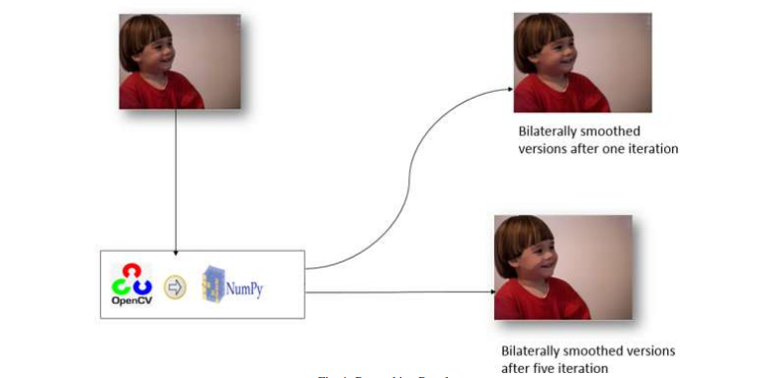

Fig.1

3.SYSTEM ANALYSIS

3.1 Functional Requirements:

1.We need an user friendly environment to set the image path.
2.We should have a save button which enables the user to save the cartoon image easily.
3.We should plot every step plots inorder to visualize clearly what is happening.
4.All the steps must be carried in a machine whose processor is above or equal to i3 in order to compute results faster and accurate.
5.The Workinng RAM of the System must be greater than or equal to 4GB

3.2 Software Requirements:

Language & Technology : Python, Open CV library
IDE : Python IDE.
Operating System : Windows XP and above.

The IDE we can use are jupyter lite , pycharm etc..
Note** : We cannot use Google collab as the google collab cannot support dynamic running which runs gui interfaces

3.3 Hardware Requirements:

Processor : i3
RAM : 4GB
Hard Disk :20GB

3.4 Feasibility study (Technical/Economical/Operational):
Training of networks for different style images is time consuming and requires lots of computation hardware(GPUs). Different content images may produce slightly different styled images. Precision of cartoon like effect entirely depends on type of content image provided.

4.SYSTEM DESIGN

4.1 System Architecture Design:

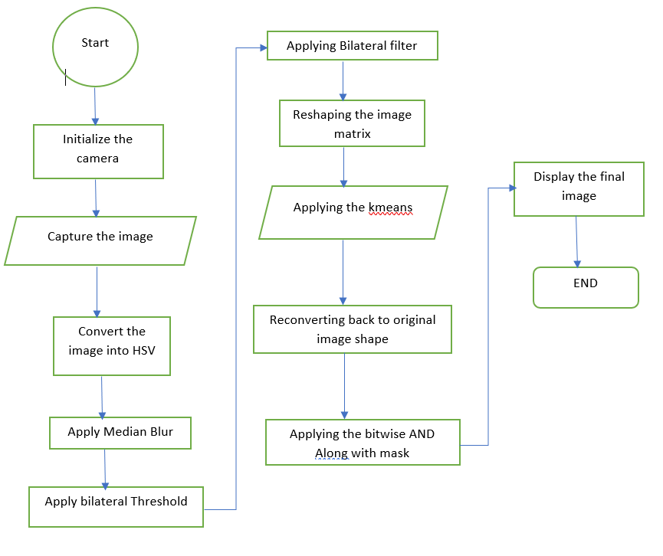

Fig.2

4.2 Data Flow Diagram:

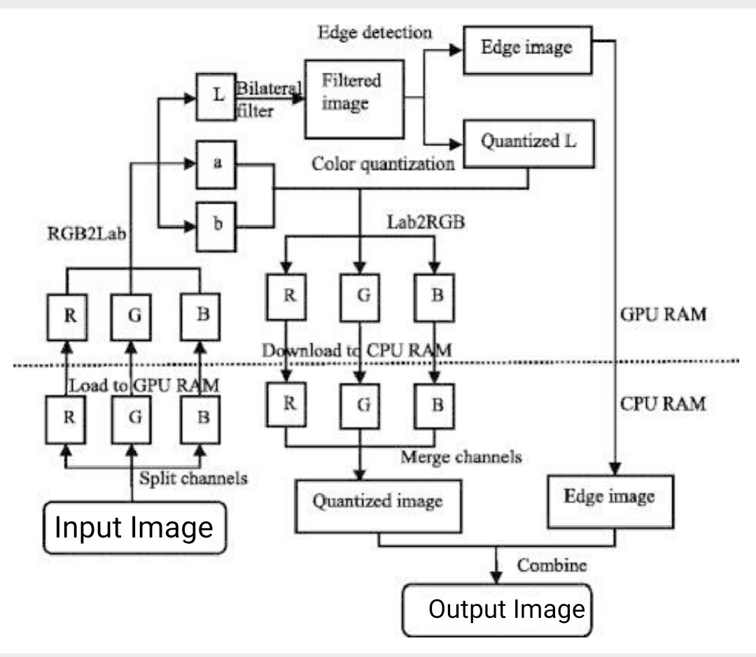
Fig 3

4.3 UML Diagrams

4.3.1 Use Case Diagram:

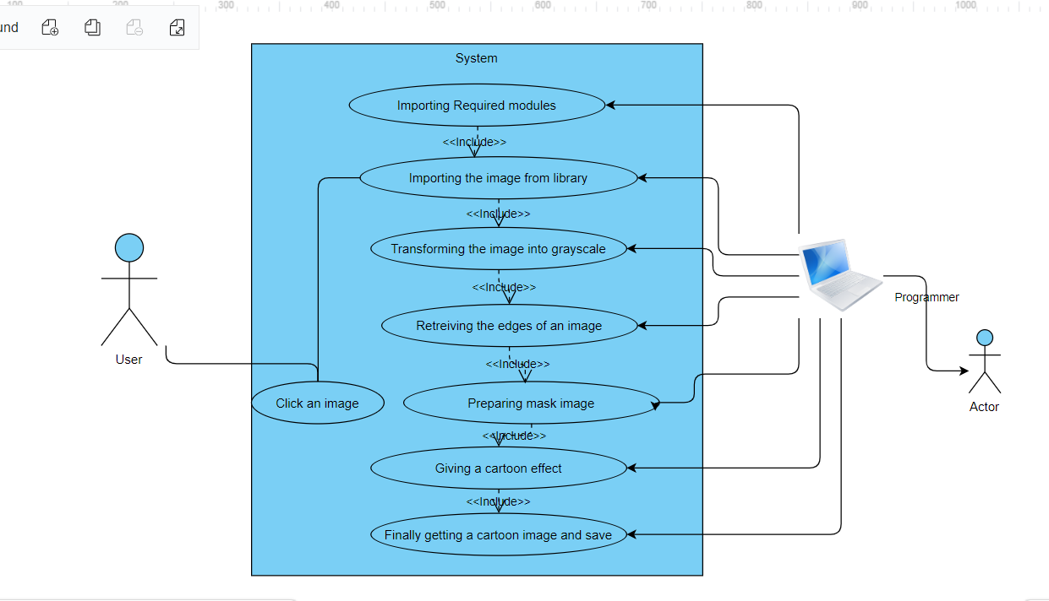
Fig 4
4.3.2 Class Diagram:

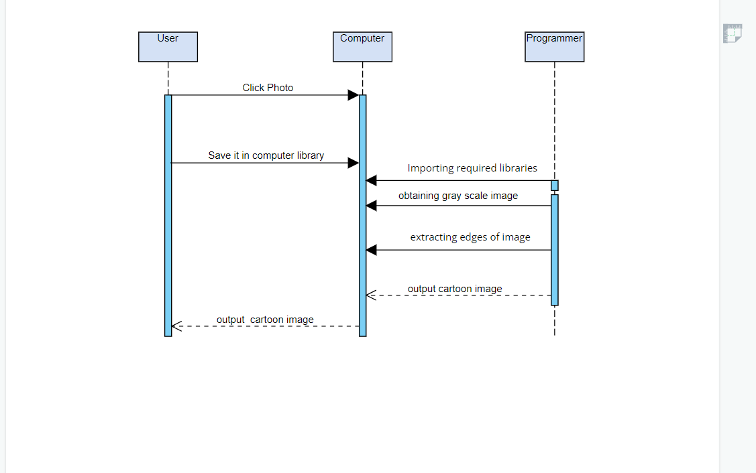

Fig 5

4.3.3 Activity Diagram:

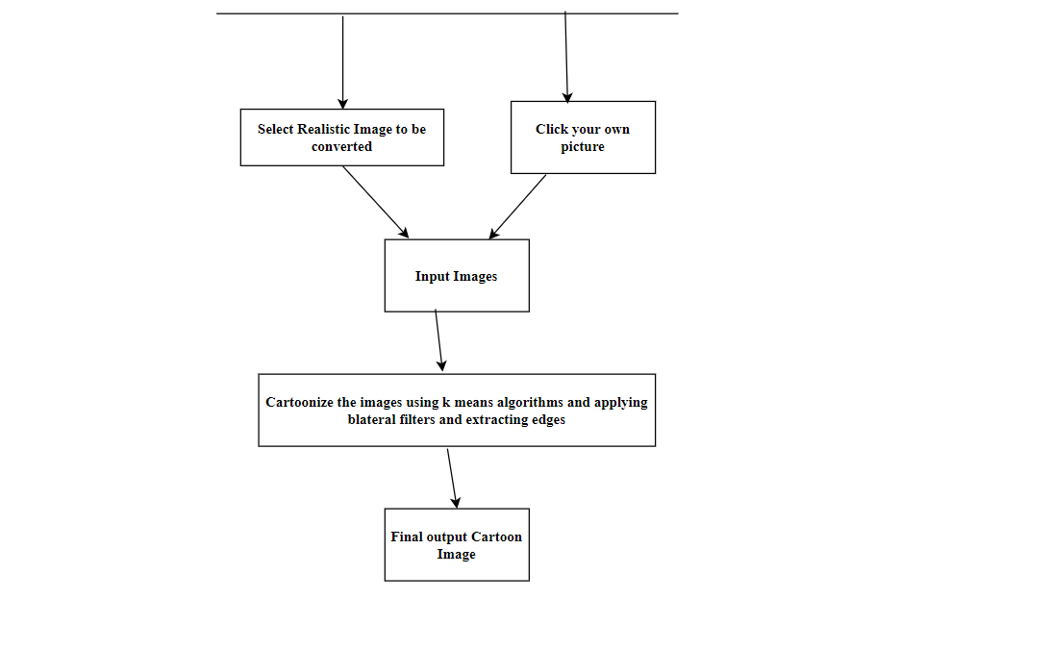

Fig 6

4.4 Modules

Python is a interpreted, intelligent, object-oriented programming language. It fuses modules, special cases, dynamic composing, extremely undeniable level unique information types, and classes. It upholds numerous programming standards past object-situated programming, like procedural and useful programming. Python consolidates momentous force with exceptionally clear punctuation. It has interfaces to numerous framework calls and libraries, just as to different window frameworks, and is extensible in C or C++. It is additionally usable as an expansion language for applications that need a programmable interface. At last, Python is convenient: it runs on numerous Unix variations including Linux and macOS, and on Windows.
Python is a high-level general-purpose programming language that can be applied to many different classes of problems.
The language comes with a large standard library that covers areas such as string processing expression, Unicode, internet protocol, software engineering, operating system interface.
Regularly, developers become hopelessly enamored with Python on account of the expanded efficiency it gives. Since there is no gathering step, the alter test-investigate cycle is amazingly quick. Troubleshooting Python programs is simple: a bug or terrible info won't ever cause a division issue. All things being equal, when the translator finds a blunder, it raises an exemption. At the point when the program doesn't get the special case, the translator prints a stack follow. A source level debugger permits investigation of neighborhood and worldwide factors, assessment of discretionary articulations, setting breakpoints, venturing through the code a line at an at once, on. The debugger is written in Python itself, vouching for Python's reflective force. Then again, regularly the speediest method to investigate a program is to add a couple of print articulations to the source: the quick alter test-troubleshoot cycle simplifies this methodology extremely powerful.
Open CV Library:
OpenCV (Open Source Computer Vision Library) is an open source PC vision and AI programming library. OpenCV was worked to give a typical framework to PC vision applications and to speed up the utilization of machine insight in the business items. Being a BSD-authorized item, OpenCV makes it simple for organizations to use and alter the code.
The library has in excess of 2500 improved calculations, which incorporates a far reaching set of both work of art and cutting edge PC vision and AI calculations. These calculations can be utilized to distinguish and perceive faces, distinguish objects, characterize human activities in recordings, track camera developments, track moving items, separate 3D models of articles, produce 3D point mists from sound system cameras, fasten pictures together to create a high goal picture of a whole scene, discover comparable pictures from a picture information base, eliminate red eyes from pictures taken utilizing streak, follow eye developments, perceive view and build up markers to overlay it with increased reality, and so on OpenCV has in excess of 47 thousand individuals of client local area and assessed number of downloads surpassing 18 million. The library is utilized broadly in organizations, research gatherings and by administrative bodies.

Along with well-established companies like Google, Yahoo, Microsoft, Intel, IBM, Sony, Honda, Toyota that employ the library, there are many startups such as Applied Minds, VideoSurf, and Zeitera, that make extensive use of OpenCV. OpenCV’s deployed uses span the range from stitching streetview images together, detecting intrusions in surveillance video in Israel, monitoring mine equipment in China, helping robots navigate and pick up objects at Willow Garage, detection of swimming pool drowning accidents in Europe, running interactive art in Spain and New York, checking runways for debris in Turkey, inspecting labels on products in factories around the world on to rapid face detection in Japan.

NumPy:

NumPy is the fundamental package for scientific computing in Python. It is a Python library that provides a multidimensional array object, various derived objects (such as masked arrays and matrices), and an assortment of routines for fast operations on arrays, including mathematical, logical, shape manipulation, sorting, selecting, I/O, discrete Fourier transforms, basic linear algebra, basic statistical operations, random simulation and much more.
At the core of the NumPy package, is the ndarray object. This encapsulates n-dimensional arrays of homogeneous data types, with many operations being performed in compiled code for performance.

easygui:

easygui is a module for GUI programming in python. using this gui module all gui interactions are invoked using function calls.
easygui is used to create boxes like ccbox,ynbox,indexbox,boolbox

imageio:

imageio is a python library module which provides an interface to read and write and visualize the which is in the form of images, animated images.

matplotlib:

matplotlib is a library in python for 2-D plots of arrays. matplotlib is a data visualization library build on numpy arrays and work with the broader scipy stack.
Benefits of visualization is it allows us visual access to huge amounts of data in easily understandable visuals. matplotlib has several plots like line, bar, scatter, histogram ,box.

Tkinter:

tkinter is one of the most commonly used GUI method. It is a python interface to the Tk GUI toolkit. Using tkinter is the fastest and easiest way to create GUI applications. Creating a GUI using tkinter is an easy task.
To create a tkinter app:
- Import the module – tkinter in the python program
- Create a container
- Add widgets to the main window/container
- Apply triggers on the added widgets.

5.IMPLEMENTATION AND RESULTS

5.1 Language / Technology Used:

We use python in this project.python is a general purpose programming language. It is used in web development and also helps in GUI programming. We use many modules and libraries like opencv , imageio ,easygui, sys,os,numpy,matlotlib to convert the image into a cartoon.
Python can serve as a scripting language for web applications, e.g., via mod_wsgi for the Apache webserver. With Web Server Gateway Interface, a standard API has evolved to facilitate these applications. Web frameworks like Django, Pylons, Pyramid, TurboGears, web2py, Tornado, Flask, Bottle, and Zope support developers in the design and maintenance of complex applications. Pyjs and IronPython can be used to develop the client-side of Ajax-based applications. SQLAlchemy can be used as a data mapper to a relational database. Twisted is a framework to program communications between computers, and is used (for example) by Dropbox.
Libraries such as NumPy, SciPy, and Matplotlib allow the effective use of Python in scientific computing,^{[192][193]} with specialized libraries such as Biopython and Astropy providing domain-specific functionality. SageMath is a computer algebra system with a notebook interface programmable in Python: its library covers many aspects of mathematics, including algebra, combinatorics, numerical mathematics, number theory, and calculus. OpenCV has Python bindings with a rich set of features for computer vision and image processing.
Python is commonly used in artificial intelligence projects and machine learning projects with the help of libraries like TensorFlow, Keras, Pytorch, and Scikit-learn. As a scripting language with a modular architecture, simple syntax, and rich text processing tools, Python is often used for natural language processing.
Python can also be used to create games, with libraries such as Pygame, which can make 2D games.
Python has been successfully embedded in many software products as a scripting language, including in finite element method software such as Abaqus, 3D parametric modeler like FreeCAD, 3D animation packages such as 3ds Max, Blender, Cinema 4D, Lightwave, Houdini, Maya, modo, MotionBuilder, Softimage, the visual effects compositor Nuke, 2D imaging programs like GIMP, Inkscape, Scribus and Paint Shop Pro,^{[202]} and musical notation programs like scorewriter and capella. GNU Debugger uses Python as a pretty printer to show complex structures such as C++ containers. Esri promotes Python as the best choice for writing scripts in ArcGIS. It has also been used in several video games, and has been adopted as first of the three available programming languages in Google App Engine, the other two being Java and Go.
Many operating systems include Python as a standard component. It ships with most Linux distributions, AmigaOS 4 (using Python 2.7), FreeBSD (as a package), NetBSD, and OpenBSD (as a package) and can be used from the command line (terminal). Many Linux distributions use installers written in Python: Ubuntu uses the Ubiquity installer, while Red Hat Linux and Fedora Linux use the Anaconda installer. Gentoo Linux uses Python in its package management system, Portage.
Python is used extensively in the information security industry, including in exploit development.
The Raspberry Pi single-board computer project has adopted Python as its main user-programming language.
LibreOffice includes Python and intends to replace Java with Python. Its Python Scripting Provider is a core feature.

5.2 Methods / Algorithms Used:

K-Means Clustering Algorithm:
K-Means Clustering is an unsupervised learning algorithm.
K-Means Clustering is an Unsupervised Learning algorithm, this algorithm groups the data sets into clusters. Here clusters have high inter class similarities and less intra class similarities .here K defines the number of pre-defined clusters, as if K=2,will have two clusters, and for K=3, will have three clusters, and so on.
This algorithm helps us to cluster the data into different groups. The simple way to find the categories of groups in the unlabeled dataset .It is a centroid-based algorithm, where each cluster has a centroid. The main objective of this algorithm is to minimize the sum of distances between the data point and their corresponding clusters.The algorithm takes the unlabeled dataset as input, divides the dataset into k-clusters,The value of k should be predetermined in this algorithm.
The k-means clustering algorithm mainly performs two tasks:
- Determines the best value for K
- Assigns each point to its closest k-center. The points which are near to the particular k-center, makes a cluster.
Therfore each cluster has points with some common features, and it is far from other clusters.The below diagram explains the working of the K-means Clustering Algorithm:
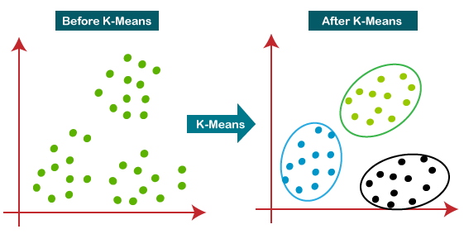
Graph-1

How does the K-Means Algorithm Work?
The working of the K-Means algorithm is explained in the below steps:
Step-1: Select the number K
Step-2: Select random K points
Step-3: Assign each point to their closest k-centroid point, which will form the predefined K clusters.
Step-4: Calculate the variance and place a new k-center centroid for every cluster.
Step-5: repeat all the steps until all the points are reassigned with new centroid point.
Step-6: The model is ready.
Suppose we have two variables M1 and M2. The x-y axis scatter plot of these two variables is given below:
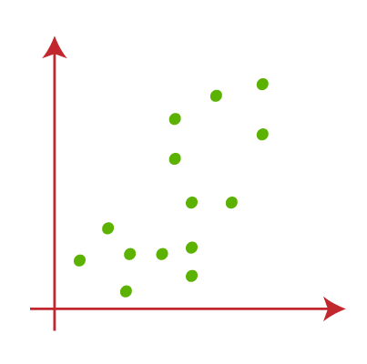
Graph-2
- Let's take number k of clusters, i.e., K=2, and make two different clusters.
- Choose some random k points or centroid to form a cluster. So, here we are selecting the below two points as k points, which are not the part of our set of input datapoints.
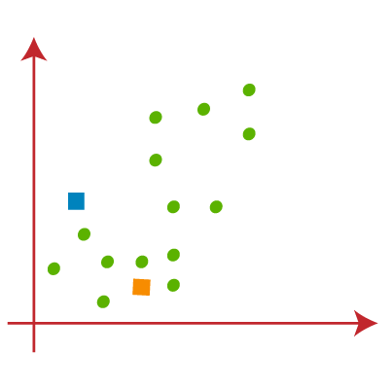
        - Graph-3
- Now we will assign each point to its closest K-point.We will caluculate it by using some mathematics i.e., calculate the distance between two points. We will also draw 2 medians
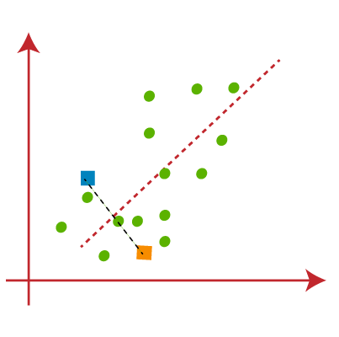
Graph-4
From the above image, it is clear that points left side of the line is near to the K1 or blue centroid, and points to the right of the line are close to the yellow centroid. Differentiate them by colouring one group with blue and another colour with yellow which makes visualisation easier
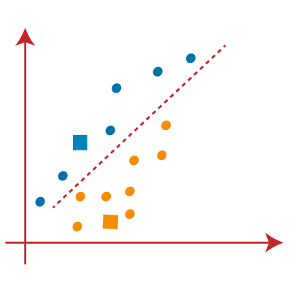
Graph-5
- we need to find the closest cluster, we will repeat the process of selecting a a new centroid. To assign new centroids, we will compute the center of gravity of these centroids
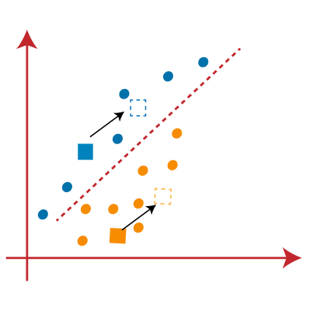
        - Graph-6
- Now, we will reassign each input datapoint to the new centroid. For this, we will find a new median line every time
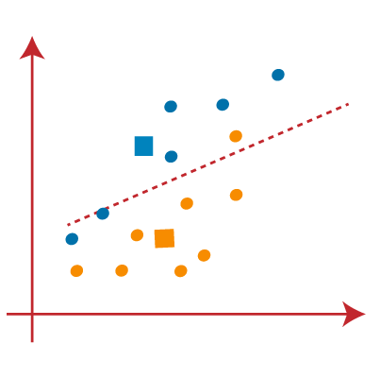
Graph-7
In the above image, we can visualise, one yellow point is on the left side of median line, and two blue points are right side of median line. All these three points will be reassigned to new centroids.
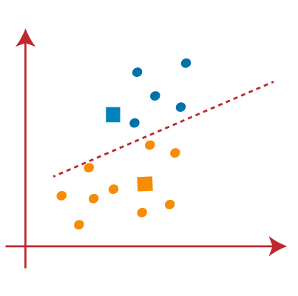
Graph-8
- We will repeat the process by finding the center of gravity of centroids.
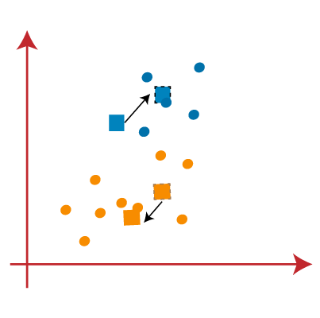
Graph-9
- As soon as we get the new centroids we will draw the median line and reassign the data points
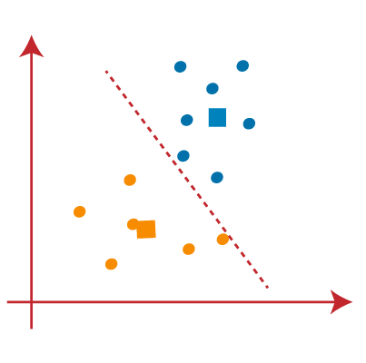
Graph-10
- In the above image, there are no dissimilar data points on either side of the line, which means our model is ready.
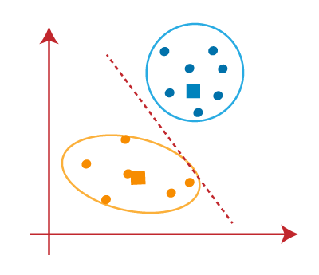
Graph-11
Our model is ready, eliminate the assumed centroids, and the final clusters will be as shown in the below image:
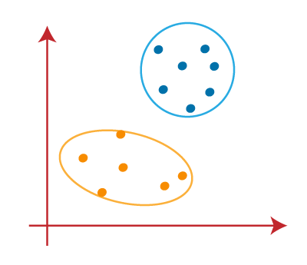
Graph-12

5.3 Sample Code

import cv2 #for image processing
import easygui #to open the filebox
import numpy as np #to store image
import imageio #to read image stored at particular path
import sys
import matplotlib.pyplot as plt
import os
import tkinter as tk
from tkinter import filedialog
from tkinter import *
from PIL import ImageTk, Image
""" fileopenbox opens the box to choose file
and help us store file path as string """
def upload():
ImagePath=easygui.fileopenbox()
cartoonify(ImagePath)
def cartoonify(ImagePath):
#read the image
originalmage = cv2.imread(ImagePath)
originalmage = cv2.cvtColor(originalmage, cv2.COLOR_BGR2RGB)
#print(image) # image is stored in form of numbers
# confirm that image is chosen
if originalmage is None:
print("Can not find any image. Choose appropriate file")
sys.exit()
ReSized1 = cv2.resize(originalmage, (960, 540))
grayScaleImage = cv2.cvtColor(originalmage, cv2.COLOR_BGR2GRAY)
ReSized2 = cv2.resize(grayScaleImage, (960, 540))
smoothGrayScale = cv2.medianBlur(grayScaleImage, 5)
ReSized3 = cv2.resize(smoothGrayScale, (960, 540))
getEdge = cv2.adaptiveThreshold(smoothGrayScale, 255,
cv2.ADAPTIVE_THRESH_MEAN_C,
cv2.THRESH_BINARY, 9, 9)
ReSized4 = cv2.resize(getEdge, (960, 540))
colorImage = cv2.bilateralFilter(originalmage, 9, 300, 300)
ReSized5 = cv2.resize(colorImage, (960, 540))
cartoonImage = cv2.bitwise_and(colorImage, colorImage, mask=getEdge)
ReSized6 = cv2.resize(cartoonImage, (960, 540))
images=[ReSized1, ReSized2, ReSized3, ReSized4, ReSized5, ReSized6]
fig, axes = plt.subplots(3,2, figsize=(8,8), subplot_kw={'xticks':[], 'yticks':[]}, gridspec_kw=dict(hspace=0.1, wspace=0.1))
for i, ax in enumerate(axes.flat):
ax.imshow(images[i], cmap='gray')
plt.show()
top=tk.Tk()
top.geometry('400x400')
top.title('Cartoonify Your Image !')
top.configure(background='white')
label=Label(top,background='#CDCDCD', font=('calibri',20,'bold'))
upload=Button(top,text="Cartoonify an Image",command=upload,padx=10,pady=5)
upload.configure(background='#364156', foreground='white',font=('calibri',10,'bold'))
upload.pack(side=TOP,pady=50)

top.mainloop();

5.4 Results (Accuracy) / Output Screens:

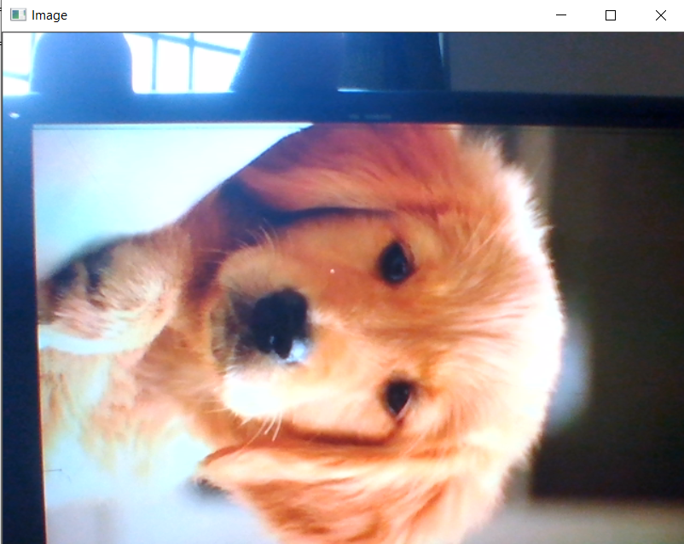

Fig 7

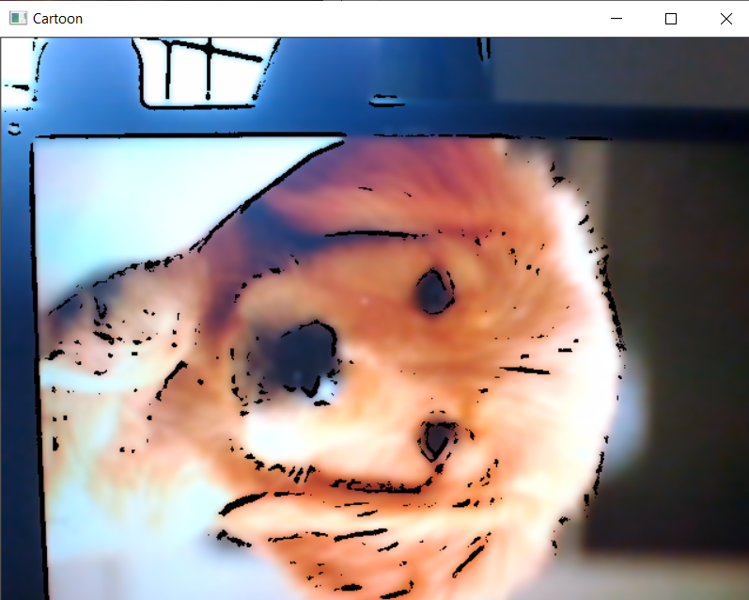

Fig 8

6.TESTING
6.1.Types of Testing:
In our Type of testing at each step we test the image and display the output plot of particular image We perform many tests and we plot 4 intermediate plots in order to obtain the final plot of our image.
Our Input Image:
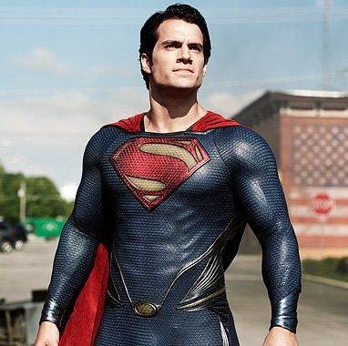
Fig 9
- Transforming an image to grayscale:
cvtColor(image, flag) is a method in cv2 which is used to transform an image into the colour-space mentioned as ‘flag’. Here, our first step is to convert the image into grayscale. Thus, we use the BGR2GRAY flag. This returns the image in grayscale.
After we display it using imshow() method.
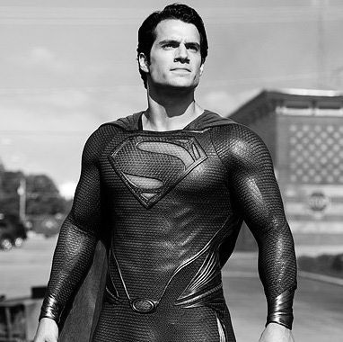 Fig 10

- Smoothening a gray scale Image:
To smoothen an image, we simply apply a blur effect. This is done using medianBlur() function. Here, the center pixel is assigned a mean value of all the pixels which fall under the kernel.

- Retrieving the Edges of an Image:

Cartoon effect has two specialties:
- Highlighted Edges
- Smooth colors
Here, we will retrieve the edges and make them visible. This is achieved by the adaptive thresholding technique. The threshold value is the mean of the neighborhood pixel values area minus the constant K. We subtract a constant K from the mean or weighted sum of the neighborhood pixels. Thresh_binary is the type of threshold applied, and the remaining parameters determine the block size.
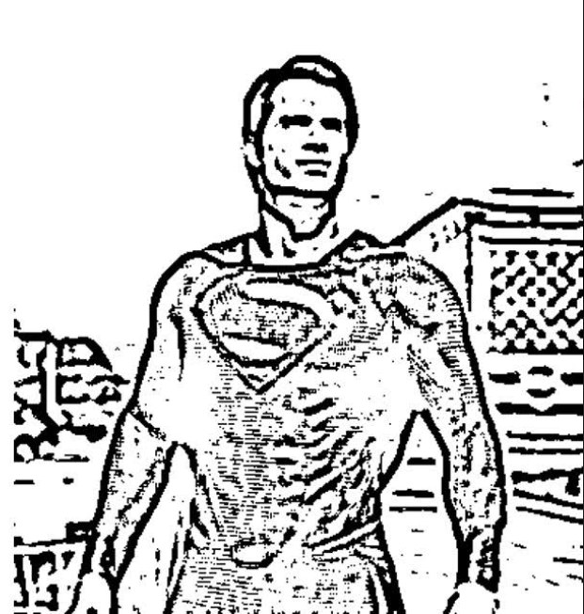
Fig 11

- Preparing Mask Image:

We prepare a color image that we mask with edges at the end to produce a cartoon image. We use bilateralFilter which removes the noise in the given image.
The parameter which is also important is the diameter of the pixel neighborhood, i.e, the number of pixels around a certain pixel which will determine its value. The next parameters are for sigmaColor and sigmaSpace. These parameters are used to give a sigma effect, i.e make an image look vicious and like water paint, removing the roughness in colors.
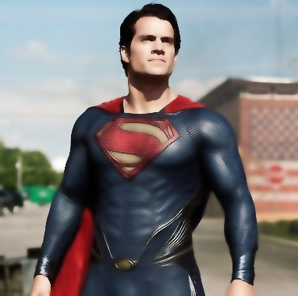
Fig 12

6.2.Test Cases:
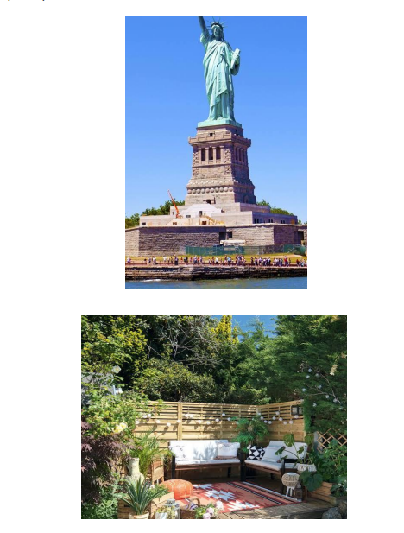

Fig 13

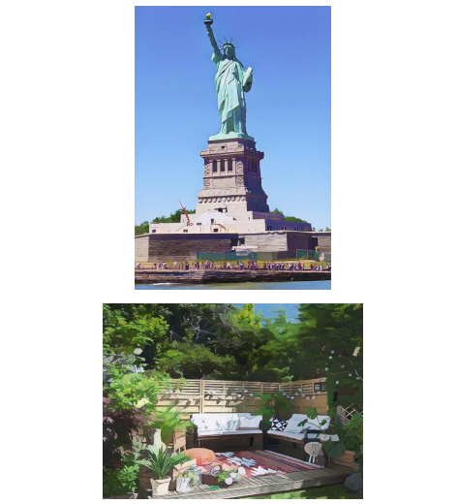
Fig 14
7.CONCLUSION

First of all, the basic tools to handle the titled problems of the thesis are incorporated. It includes origin and history of image processing, different types of uncertain environment, existing methods for cartoon imaging. Amid the previous three decades, the topic of image processing has gained vital name and recognition among researchers because of their frequent look in varied and widespread applications within the field of various branches of science and engineering. As an example, image processing is helpful to issues in signature recognition, digital video processing, Remote Sensing and finance. Conclusion and Future Directions Firstly, we use high-resolution camera to take picture of the internal structure of the wire. Secondly, we use OpenCV image processing functions to implement image pre-processing. Thirdly we use morphological opening and closing operations to segment image because of their blur image edges. The main attraction of the paper is to solve different types of images having one object, two object and three object which can’t be solved by any of the exiting methods but can be solved by our proposed method.

8.FUTURE SCOPE
- Currently the system is facing issues with face cartoonization. This can be improved by providing more facials data with different perspective to the model. The resolution of the output also need to be increased.
- User will be provided with a set of pretrained style images to choose from. Based on the chosen style and the content image provided by the user, the Resulting image with cartoon like effect is generated by the program.
- The implementation is based on of the combination of Gatys' A Neural Algorithm of Artistic Style, Johnson's Perceptual Losses for Real-Time Style Transfer and SuperResolution, and Ulyanov's Instance Normalization
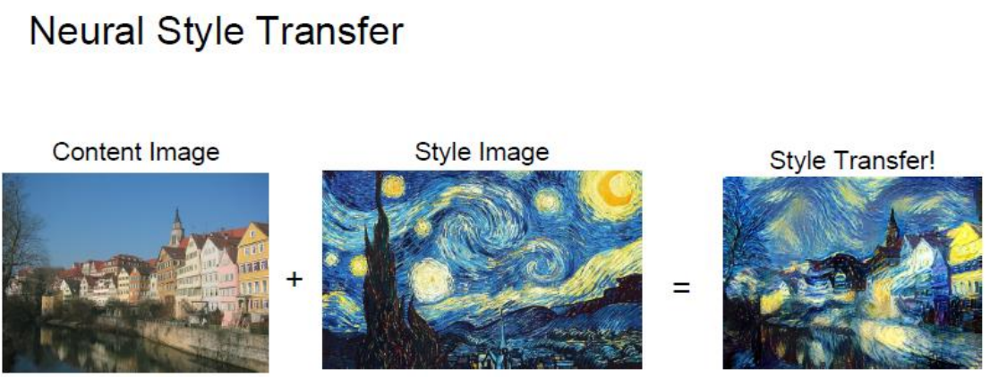

Fig 16

9.BIBILOGRAPHY

1. https://ieeexplore.ieee.org/document/5563326
2. https://www.academia.edu/
3.https://subscription.packtpub.com/

